





Weekly Newsletter
Mrs. Reece’s
August 25, 2017

Reading- *Our Names
*Independent learning center
routines

Writing- * Learning writer’s workshop routines
* Getting writing ideas/
brainstorming

Math-Numbers 0-10

Leader in Me Habit- Proactive

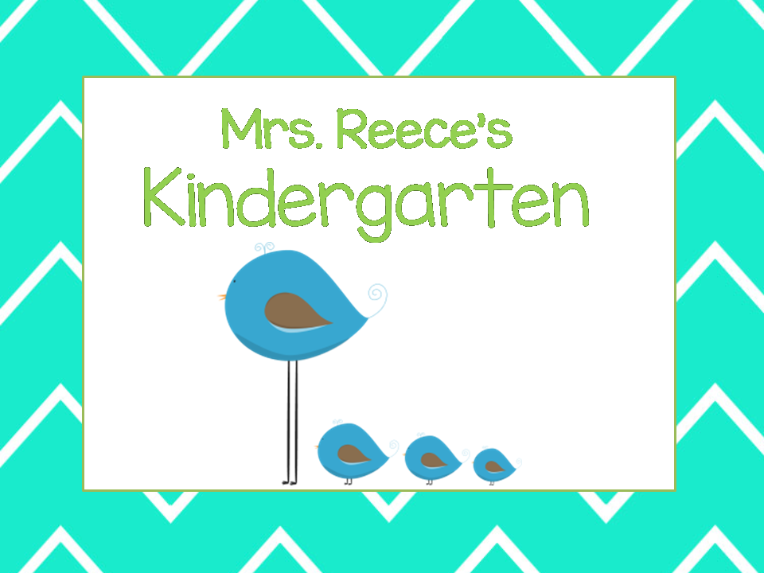

Technology
Visit our class website and blog
www.mrsreeceskindergarten.weebly.com

Sign up for Remind announcements

We have a class Facebook and Twitter account!
- Please return all beginning of the year forms.
- Your child is encouraged to bring a water bottle.
- We are still collecting snacks contributions for class.

Sep 4- Labor Day
No School

Sep 7- PTO Meeting

Reminders
Upcoming Events

