





Weekly Newsletter
Mrs. Reece’s
September 21, 2017

Reading- *Theme- Apples
*Story- Apples
*Rhyming Words

Writing- * Labeling Pictures
* Writing the sounds we hear

Math-Numbers 6-10

Leader in Me Habit- Proactive

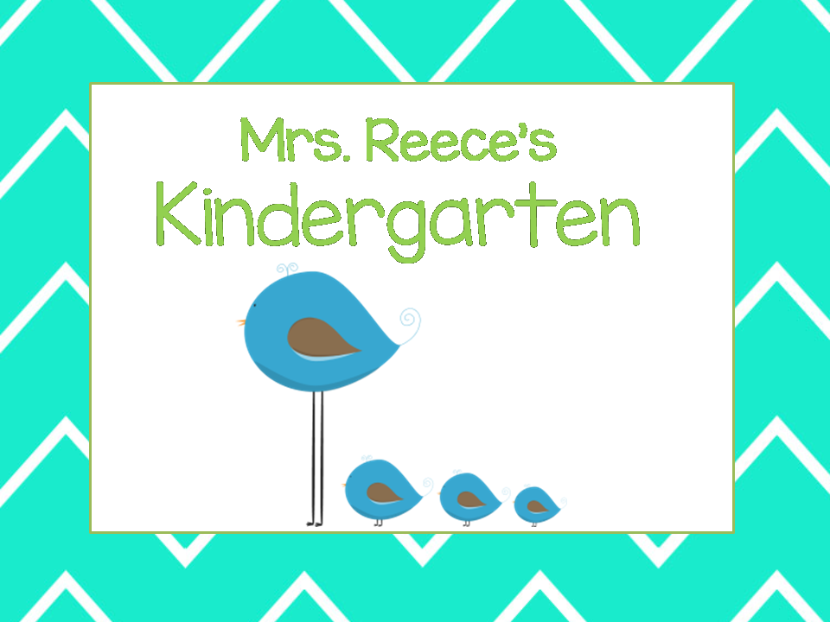

Technology
-I try to use technology to keep parents informed and offer convenient ways to communicate.
-Sign up for Remind

- Your child is encouraged to bring a water bottle.
-We are still collecting snack donations. We appreciate every family’s contribution..

Sep 26- Incredible Indian Pow-Wow
Oct. 3- Tell Me a Story Night
Oct 10- Field Trip
Oct. 24- PM Parent/Teacher Conf.
Oct 26- AM Parent/Teacher Conf.

Reminders
Upcoming Events
- Text my class code @9h966h to 81010.
- Reply to the message from the Remind team with your first and last name, and you're in!

